Question:- Thank you so much, its totally clear to me except one step.
I am bit confused here because of below step, if i will create this project using claude code only then how can i connect PowerBI with our project this is something i don't know, can you help me out here ?

Claude responded: Great question!
Great question! The good news is this is actually the simplest part — Claude Code doesn't need to "connect" to Power BI directly. Here's how it works:

How the Connection Works
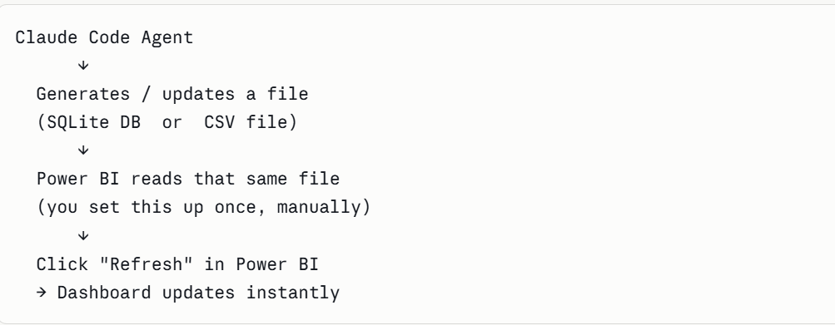
Power BI doesn't care who created the data file — it just reads whatever is there. So Claude Code's job is simply to keep the file updated, and Power BI's job is to read and visualize it.

Two Simple Options
Option A — CSV Files (Easiest, Recommended for you)
Your Report Agent in Claude Code exports analysis results as CSV files:
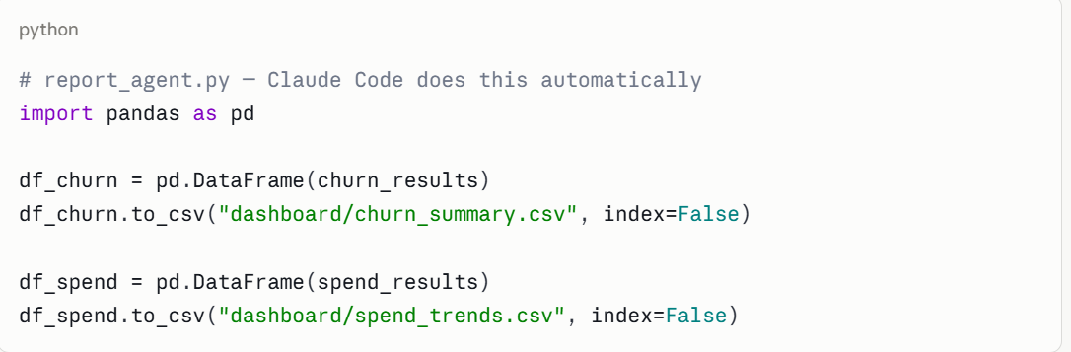
Then in Power BI Desktop, you do this one time manually:
- Get Data → Text/CSV → point to your dashboard/ folder
- Build your visuals once
- Every time Claude Code runs and updates the CSVs, just hit Refresh in Power BI
That's it. No coding in Power BI at all.

Option B — SQLite Direct (Slightly more setup, looks more impressive)
Power BI can connect directly to SQLite using a free ODBC driver:
- Download & install SQLite ODBC Driver (free, one-time setup)
- In Power BI → Get Data → ODBC → point to your banking_mock.db file
- Select your tables, build visuals
- Hit Refresh anytime Claude Code has updated the database

My Recommendation for Your Project
Go with Option A (CSV). Here's why:
- You already know Excel/CSV exports from your Coforge work
- Your Report Agent naturally produces CSVs anyway
- Power BI + CSV is something every recruiter understands
- Zero extra tools or drivers needed
- In interviews you can honestly say "the agent auto-generates structured CSVs that feed directly into the Power BI dashboard" — that sounds great and is 100% accurate

What Your Full Flow Looks Like
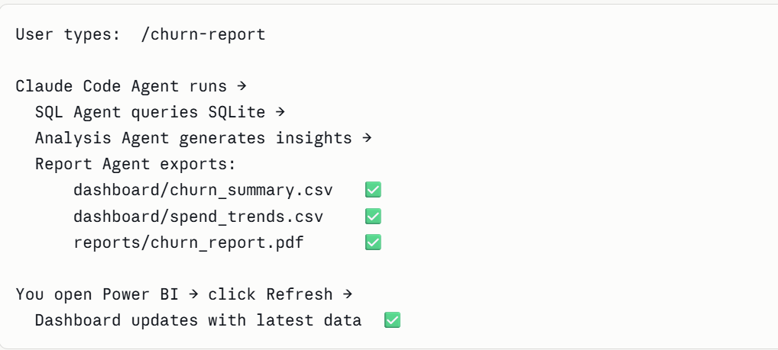
So to summarize — Claude Code handles all the intelligence and data work. Power BI is just a viewer that reads the files Claude Code produces. You set up the Power BI connection once manually, and after that it's fully automated on the Claude Code side.
Does this make it clearer? Ready to start Week 1? 😊

